McKnight's Physical Geography, 12e (Hess)
Chapter 1 Introduction to Earth

1) The word geography comes from the Greek, meaning ________.
A) the study of rocks
B) description of Earth
C) planet measurement
D) drawing of maps
E) the study of human culture
Answer: B
Diff: 1
Topic/Section: 1.1 Geography and Science
Learning Outcome: 1.1 Distinguish the key concerns for geographers who study the world.
Natl. Geog Stds: GS4
Global Sci Stds: G7
Bloom's Taxonomy: Remembering/Understanding

2) Which of the following would NOT be a major topic taught in a course of introductory physical geography?
A) Climate
B) Plants
C) Soil
D) Landforms
E) Population
Answer: E
Diff: 2
Topic/Section: 1.1 Geography and Science
Learning Outcome: 1.1 Distinguish the key concerns for geographers who study the world.
Natl. Geog Stds: GS7
Global Sci Stds: G7
Bloom's Taxonomy: Remembering/Understanding

3) The elements of geography can be grouped into two categories ________.
A) plants and animals
B) landform geography and political geography
C) weather and climate and geology
D) human geography and physical geography
E) economic activities and physical geography
Answer: D
Diff: 1
Topic/Section: 1.1 Geography and Science
Learning Outcome: 1.1 Distinguish the key concerns for geographers who study the world.
Natl. Geog Stds: GS4
Global Sci Stds: G7
Bloom's Taxonomy: Remembering/Understanding
4)
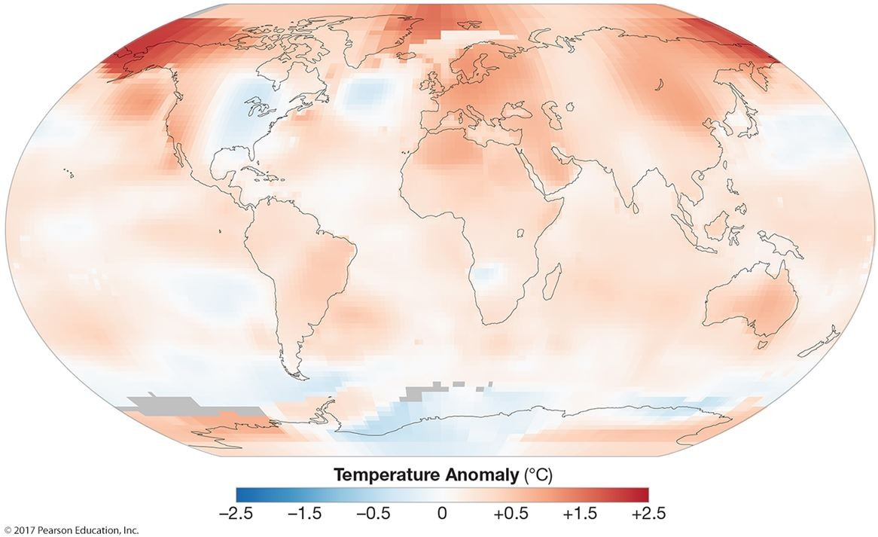

This figure shows temperature anomalies. Anomalies represent ________.
A) maximum temperatures
B) minimum temperatures
C) average temperatures
D) extreme temperatures
E) temperature changes
Answer: E
Diff: 2
Topic/Section: 1.1 Geography and Science
Learning Outcome: 1.1 Distinguish the key concerns for geographers who study the world.
Natl. Geog Stds: GS16
Global Sci Stds: G3
Bloom's Taxonomy: Remembering/Understanding

5) Geography is ________.
A) a physical science
B) a social science
C) an art, not a science
D) much the same as geology
E) a combination of physical and social sciences
Answer: E
Diff: 1
Topic/Section: 1.1 Geography and Science
Learning Outcome: 1.1 Distinguish the key concerns for geographers who study the world.
Natl. Geog Stds: GS4
Global Sci Stds: G7
Bloom's Taxonomy: Remembering/Understanding
6) Geography has much to offer in the study of globalization because it ________.
A) is the best discipline
B) ignores science to focus on understanding
C) is not a narrow discipline
D) has a sharp focus on cultural affairs
E) is the most mathematical discipline
Answer: C
Diff: 1
Topic/Section: 1.1 Geography and Science
Learning Outcome: 1.1 Distinguish the key concerns for geographers who study the world.
Natl. Geog Stds: GS4
Global Sci Stds: G7
Bloom's Taxonomy: Remembering/Understanding

7) In science, the term theory is ________.
A) a first guess
B) an unsupported hunch
C) a revolution around the Earth
D) not relevant
E) a well-tested explanation for a natural phenomenon
Answer: E
Diff: 1
Topic/Section: 1.1 Geography and Science
Learning Outcome: 1.2 Analyze how geographers use science to explain and understand the natural environment.
Natl. Geog Stds: GS3
Global Sci Stds: G1
Bloom's Taxonomy: Remembering/Understanding

8) The acceptance of a theory or hypothesis is based on ________.
A) a preponderance of evidence
B) a hunch
C) a belief
D) the pronouncements of authorities
E) common sense
Answer: A
Diff: 1
Topic/Section: 1.1 Geography and Science
Learning Outcome: 1.2 Analyze how geographers use science to explain and understand the natural environment.
Natl. Geog Stds: GS3
Global Sci Stds: G1
Bloom's Taxonomy: Remembering/Understanding
9) Which of the following statements is out of order in the ideal application of the scientific method?
A) Observe a phenomenon that stimulates a question.
B) Design an experiment.
C) Observe the outcome of an experiment.
D) Formulate a rule.
E) Make a hypothesis.
Answer: E
Diff: 1
Topic/Section: 1.1 Geography and Science
Learning Outcome: 1.2 Analyze how geographers use science to explain and understand the natural environment.
Natl. Geog Stds: GS3
Global Sci Stds: G1
Bloom's Taxonomy: Remembering/Understanding

10) The ________ is a basic unit of distance in the Système International (metric system).
A) mole
B) kilogram
C) ampere
D) degree Celsius
E) meter
Answer: E
Diff: 1
Topic/Section: 1.1 Geography and Science
Learning Outcome: 1.2 Analyze how geographers use science to explain and understand the natural environment.
Natl. Geog Stds: GS1
Global Sci Stds: G4
Bloom's Taxonomy: Remembering/Understanding

11) The process of voluntarily creating and sharing geography information is known as ________.
A) VGI
B) facilitated science
C) GIS
D) GPS
E) geocaching
Answer: A
Diff: 1
Topic/Section: 1.1 Geography and Science
Learning Outcome: 1.2 Analyze how geographers use science to explain and understand the natural environment.
Natl. Geog Stds: GS1
Global Sci Stds: G6
Bloom's Taxonomy: Remembering/Understanding
12) The ________ is a basic Système International (metric system) unit of mass.
A) ton
B) gram
C) ampere
D) mole
E) meter
Answer: B
Diff: 1
Topic/Section: 1.1 Geography and Science
Learning Outcome: 1.2 Analyze how geographers use science to explain and understand the natural environment.
Natl. Geog Stds: GS3
Global Sci Stds: G3
Bloom's Taxonomy: Remembering/Understanding

13) Which of the following is NOT a concept of volunteered geographic activity?
A) Citizens as sensors
B) Crisis mapping
C) Reporting sightings of animals and plants
D) Participation in NASA's astronaut program
E) Reporting weather at your house
Answer: D
Diff: 2
Topic/Section: 1.1 Geography and Science
Learning Outcome: 1.2 Analyze how geographers use science to explain and understand the natural environment.
Natl. Geog Stds: GS1
Global Sci Stds: G2
Bloom's Taxonomy: Applying/Analyzing

14) Your textbook uses the following as its units of measurement.
A) Metric
B) English
C) English and metric
Answer: C
Diff: 1
Topic/Section: 1.1 Geography and Science
Learning Outcome: 1.2 Analyze how geographers use science to explain and understand the natural environment.
Natl. Geog Stds: GS3
Global Sci Stds: G4
Bloom's Taxonomy: Remembering/Understanding
15) Your textbook asserts global environmental change is ________.
A) not happening
B) not caused by humans
C) partially caused by humans
D) about to cause life on Earth to cease
E) mostly occurring over time in scales of millions of years
Answer: C
Diff: 2
Topic/Section: 1.1 Geography and Science
Learning Outcome: 1.1 Distinguish the key concerns for geographers who study the world.
Natl. Geog Stds: GS14
Global Sci Stds: G7
Bloom's Taxonomy: Remembering/Understanding

16) The solid, inorganic portion of the Earth system is known as the ________.
A) Earth
B) lithosphere
C) hydrosphere
D) atmosphere
E) biosphere
Answer: B
Diff: 1
Topic/Section: 1.2 Environmental Spheres and Earth Systems
Learning Outcome: 1.3 Convert a quantity from S.I. units to English units and vice versa.
Natl. Geog Stds: GS3
Global Sci Stds: G7
Bloom's Taxonomy: Remembering/Understanding
17)
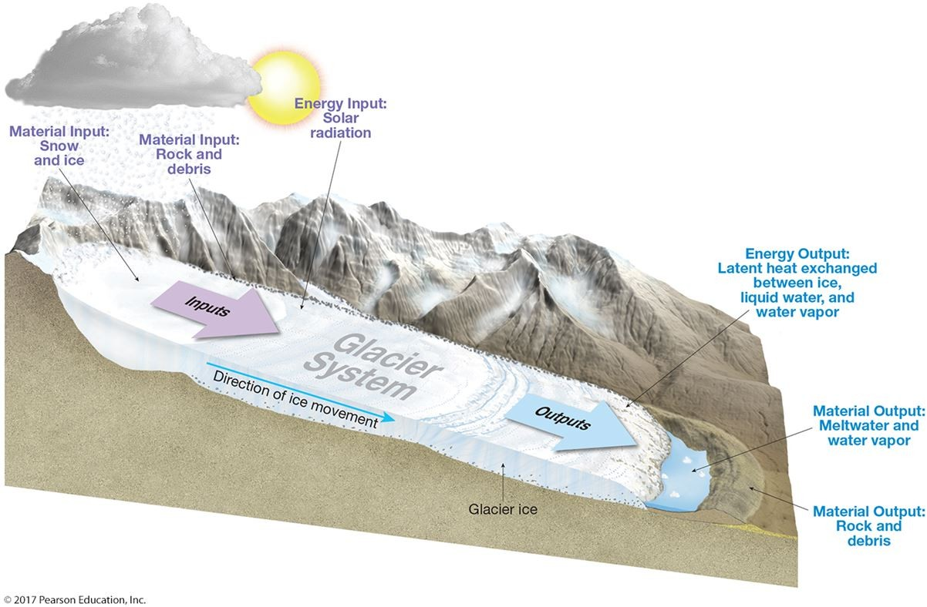

This figure shows a mountain glacier system. By looking at the inputs and outputs, it is obvious that this system is ________.
A) closed
B) a positive feedback loop
C) a negative feedback loop
D) unequal
E) open
Answer: E
Diff: 2
Topic/Section: 1.2 Environmental Spheres and Earth Systems
Learning Outcome: 1.4 Identify the four environmental "spheres" of Earth.
Natl. Geog Stds: GS3
Global Sci Stds: G3
Bloom's Taxonomy: Applying/Analyzing

18) Which of the following subsystems includes all living things on Earth?
A) Atmosphere
B) Biosphere
C) Hydrosphere
D) Lithosphere
E) Stratosphere
Answer: B
Diff: 1
Topic/Section: 1.2 Environmental Spheres and Earth Systems
Learning Outcome: 1.3 Convert a quantity from S.I. units to English units and vice versa.
Natl. Geog Stds: GS3
Global Sci Stds: G4
Bloom's Taxonomy: Remembering/Understanding
19) The ________ is the environmental sphere that encompasses water in all its forms and locations.
A) lithosphere
B) hydrosphere
C) geosphere
D) atmosphere
E) biosphere
Answer: B
Diff: 1
Topic/Section: 1.2 Environmental Spheres and Earth Systems
Learning Outcome: 1.3 Convert a quantity from S.I. units to English units and vice versa.
Natl. Geog Stds: GS3
Global Sci Stds: G7
Bloom's Taxonomy: Remembering/Understanding

20) Earth systems resist change but there are times when the system can change abruptly or become unstable. This is known as a ________.
A) human mistake
B) negative feedback loop
C) equilibrium condition
D) tipping point
E) quantum moment
Answer: D
Diff: 1
Topic/Section: 1.2 Environmental Spheres and Earth Systems
Learning Outcome: 1.4 Identify the four environmental "spheres" of Earth.
Natl. Geog Stds: GS3
Global Sci Stds: G7
Bloom's Taxonomy: Remembering/Understanding

21) Fact: The Arctic latitudes are warming, which has released methane (a greenhouse gas) from thawing Arctic permafrost. This has increased the rate of warming in the Arctic. Systems analysis would label this as ________.
A) an open system
B) a closed system
C) a negative feedback loop
D) a positive feedback loop
E) an equilibrium condition
Answer: D
Diff: 2
Topic/Section: 1.2 Environmental Spheres and Earth Systems
Learning Outcome: 1.4 Identify the four environmental "spheres" of Earth.
Natl. Geog Stds: GS2, GS3
Global Sci Stds: G2
Bloom's Taxonomy: Applying/Analyzing
22) The atmosphere, biosphere, lithosphere, and hydrosphere are considered to be ________.
A) independent of one another
B) open subsystems
C) closed subsystems
D) exchanging mass but not energy
E) exchanging energy but not mass
Answer: B
Diff: 2
Topic/Section: 1.2 Environmental Spheres and Earth Systems
Learning Outcome: 1.4 Identify the four environmental "spheres" of Earth.
Natl. Geog Stds: GS3
Global Sci Stds: G2
Bloom's Taxonomy: Applying/Analyzing

23) The lithosphere is ________.
A) landforms
B) landforms and oceans
C) the main Earth subsystem
D) not one of the Earth's subsystems
E) another name for the atmosphere
Answer: D
Diff: 1
Topic/Section: 1.2 Environmental Spheres and Earth Systems
Learning Outcome: 1.4 Identify the four environmental "spheres" of Earth.
Natl. Geog Stds: GS3
Global Sci Stds: G2
Bloom's Taxonomy: Remembering/Understanding

24) ________ is the deepest spot in the ocean.
A) The Hudson Canyon
B) The Grand Canyon
C) The Mariana Trench
D) The middle of the Atlantic Ocean
E) Just offshore of California
Answer: C
Diff: 1
Topic/Section: 1.3 Earth and the Solar System
Learning Outcome: 1.6 Describe Earth's relationships within the solar system.
Natl. Geog Stds: GS4
Global Sci Stds: G2
Bloom's Taxonomy: Remembering/Understanding
25) The response to Earth's rotation is ________.
A) wind
B) polar flattening
C) equatorial flattening
D) faulting creating Death Valley
E) the collision of plates causing Mt. Everest
Answer: C
Diff: 1
Topic/Section: 1.3 Earth and the Solar System
Learning Outcome: 1.6 Describe Earth's relationships within the solar system.
Natl. Geog Stds: GS4
Global Sci Stds: G2
Bloom's Taxonomy: Remembering/Understanding

26) The first nearly correct measurement of the Earth's circumference was made ________.
A) by the first humans
B) about 2,200 years ago
C) by Italian scholars during the Renaissance
D) by Columbus
E) by satellite
Answer: B
Diff: 1
Topic/Section: 1.3 Earth and the Solar System
Learning Outcome: 1.6 Describe Earth's relationships within the solar system.
Natl. Geog Stds: GS4
Global Sci Stds: G2
Bloom's Taxonomy: Remembering/Understanding

27) Our sun is one of ________ (of) stars in the Milky Way Galaxy
A) hundreds
B) thousands
C) hundreds of thousands
D) a few million
E) many billions
Answer: E
Diff: 2
Topic/Section: 1.3 Earth and the Solar System
Learning Outcome: 1.5 Explain how the concept of Earth systems helps us understand the interrelationships of the four environmental "spheres" of Earth.
Natl. Geog Stds: GS4
Global Sci Stds: G2
Bloom's Taxonomy: Applying/Analyzing
28) Earth's diameter is ________ kilometers (miles).
A) 13 (8)
B) 130 (79)
C) 1,300 (780)
D) 13,000 (7,930)
E) 130,000 (79,300)
Answer: D
Diff: 1
Topic/Section: 1.3 Earth and the Solar System
Learning Outcome: 1.6 Describe Earth's relationships within the solar system.
Natl. Geog Stds: GS4
Global Sci Stds: G2
Bloom's Taxonomy: Remembering/Understanding

29)
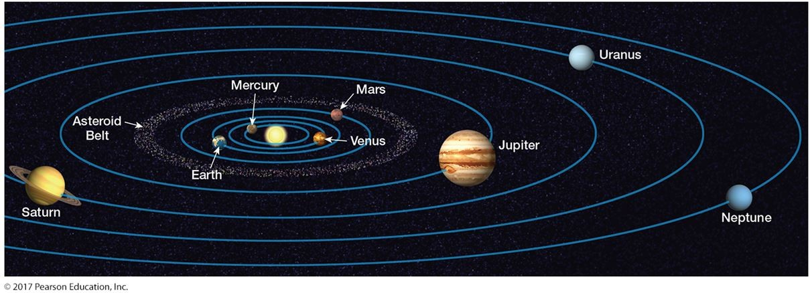

This figure shows our solar system. This figure does not show the Kuiper Belt. Where is the Kuiper Belt?
A) Next to the sun
B) Between the Earth and Moon
C) Near the terrestrial planets
D) Beyond Neptune
E) In an orbit around Mars
Answer: D
Diff: 2
Topic/Section: 1.3 Earth and the Solar System
Learning Outcome: 1.4 Identify the four environmental "spheres" of Earth.
Natl. Geog Stds: GS4
Global Sci Stds: G3
Bloom's Taxonomy: Applying/Analyzing
30)
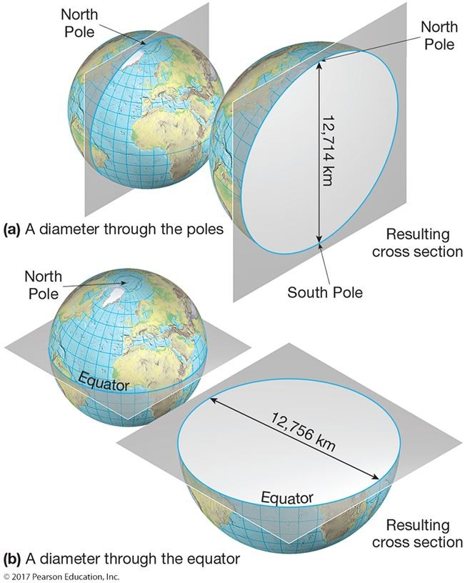

This figure shows that Earth is ________.
A) round
B) flat
C) an oblate spheroid
D) solid in its middle
E) an ellipsoid
Answer: C
Diff: 1
Topic/Section: 1.3 Earth and the Solar System
Learning Outcome: 1.6 Describe Earth's relationships within the solar system.
Natl. Geog Stds: GS1
Global Sci Stds: G3
Bloom's Taxonomy: Remembering/Understanding
31) The Sun is a star in the ________ galaxy.
A) Orion
B) Milky Way
C) Proxima Centauri
D) Alpha Centauri
E) Betelgeuse
Answer: B
Diff: 1
Topic/Section: 1.3 Earth and the Solar System
Learning Outcome: 1.5 Explain how the concept of Earth systems helps us understand the interrelationships of the four environmental "spheres" of Earth.
Natl. Geog Stds: GS4
Global Sci Stds: G2
Bloom's Taxonomy: Remembering/Understanding

32) A nebula is a ________.
A) bright star
B) black hole
C) faded star
D) cloud of gas and dust
E) small comet
Answer: D
Diff: 1
Topic/Section: 1.3 Earth and the Solar System
Learning Outcome: 1.4 Identify the four environmental "spheres" of Earth.
Natl. Geog Stds: GS4
Global Sci Stds: G2
Bloom's Taxonomy: Remembering/Understanding

33) The surfaces of the inner, terrestrial planets of our solar system are composed of ________.
A) gases
B) frozen water
C) frozen carbon dioxide
D) molten lava
E) mineral matter
Answer: E
Diff: 1
Topic/Section: 1.3 Earth and the Solar System
Learning Outcome: 1.5 Explain how the concept of Earth systems helps us understand the interrelationships of the four environmental "spheres" of Earth.
Natl. Geog Stds: GS4
Global Sci Stds: G2
Bloom's Taxonomy: Remembering/Understanding
34) The Earth is one of ________ planets in the solar system.
A) four
B) eight
C) twenty
D) thirty six
E) over one hundred
Answer: B
Diff: 1
Topic/Section: 1.3 Earth and the Solar System
Learning Outcome: 1.5 Explain how the concept of Earth systems helps us understand the interrelationships of the four environmental "spheres" of Earth.
Natl. Geog Stds: GS4
Global Sci Stds: G7
Bloom's Taxonomy: Remembering/Understanding

35) Earth is ________.
A) one of the Jovian planets
B) one of the largest planets
C) the smallest planet
D) one of the inner planets
E) one of the planets with the most gas
Answer: D
Diff: 1
Topic/Section: 1.3 Earth and the Solar System
Learning Outcome: 1.5 Explain how the concept of Earth systems helps us understand the interrelationships of the four environmental "spheres" of Earth.
Natl. Geog Stds: GS3
Global Sci Stds: G2
Bloom's Taxonomy: Remembering/Understanding

36) Pluto is now classified as a ________.
A) comet
B) moon
C) plutoid
D) meteorite
E) protostar
Answer: C
Diff: 1
Topic/Section: 1.3 Earth and the Solar System
Learning Outcome: 1.5 Explain how the concept of Earth systems helps us understand the interrelationships of the four environmental "spheres" of Earth.
Natl. Geog Stds: GS4
Global Sci Stds: G7
Bloom's Taxonomy: Remembering/Understanding
37) The shape of the Milky Way is similar to a(n) ________.
A) circle
B) sphere
C) spiral-shaped disk
D) pancake
E) oblate spheroid
Answer: C
Diff: 1
Topic/Section: 1.3 Earth and the Solar System
Learning Outcome: 1.5 Explain how the concept of Earth systems helps us understand the interrelationships of the four environmental "spheres" of Earth.
Natl. Geog Stds: GS4
Global Sci Stds: G2
Bloom's Taxonomy: Remembering/Understanding

38) The birth of the solar system occurred ________.
A) about 500 million years ago
B) about 5 billion years ago
C) about 40 billion years ago
D) about 500 billion years ago
E) about 5 million years ago
Answer: B
Diff: 1
Topic/Section: 1.3 Earth and the Solar System
Learning Outcome: 1.5 Explain how the concept of Earth systems helps us understand the interrelationships of the four environmental "spheres" of Earth.
Natl. Geog Stds: GS4
Global Sci Stds: G2
Bloom's Taxonomy: Remembering/Understanding

39) The Milky Way is a galaxy some ________ light years in diameter.
A) 10
B) 100
C) 1,000
D) 10,000
E) 100,000
Answer: E
Diff: 2
Topic/Section: 1.3 Earth and the Solar System
Learning Outcome: 1.5 Explain how the concept of Earth systems helps us understand the interrelationships of the four environmental "spheres" of Earth.
Natl. Geog Stds: GS4
Global Sci Stds: G2
Bloom's Taxonomy: Remembering/Understanding
40) The solar system's Jovian planets are most likely composed of ________.
A) gas
B) interstellar dust
C) granite
D) basalt
E) water
Answer: A
Diff: 1
Topic/Section: 1.3 Earth and the Solar System
Learning Outcome: 1.5 Explain how the concept of Earth systems helps us understand the interrelationships of the four environmental "spheres" of Earth.
Natl. Geog Stds: GS4
Global Sci Stds: G2
Bloom's Taxonomy: Remembering/Understanding

41) This event took place approximately 13.7 billion years ago.
A) Formation of the Earth
B) The first volcanoes
C) The big bang
D) Formation of the solar system
E) Formation of our Sun
Answer: C
Diff: 1
Topic/Section: 1.3 Earth and the Solar System
Learning Outcome: 1.6 Describe Earth's relationships within the solar system.
Natl. Geog Stds: GS4
Global Sci Stds: G2
Bloom's Taxonomy: Remembering/Understanding

42) Which of the following occurred first?
A) The Sun
B) The Milky Way galaxy
C) The big bang
D) Earth
E) A nebula
Answer: C
Diff: 2
Topic/Section: 1.3 Earth and the Solar System
Learning Outcome: 1.5 Explain how the concept of Earth systems helps us understand the interrelationships of the four environmental "spheres" of Earth.
Natl. Geog Stds: GS4
Global Sci Stds: G2
Bloom's Taxonomy: Applying/Analyzing
43) Eratosthenes, who lived 2,200 years ago, correctly deduced ________.
A) the height of Earth's tallest mountain
B) the deepest spot in the oceans
C) the spherical shape of Earth
D) that continents slowly move
E) that Greek summers are caused by hot weather
Answer: C
Diff: 1
Topic/Section: 1.3 Earth and the Solar System
Learning Outcome: 1.6 Describe Earth's relationships within the solar system.
Natl. Geog Stds: GS4
Global Sci Stds: G2
Bloom's Taxonomy: Remembering/Understanding

44) The altitudinal difference (relief) between the top of the tallest mountain and the bottom of the deepest ocean trench is closest to ________ kilometers (miles).
A) 20 (12)
B) 200 (122)
C) 2,000 (1,220)
D) 20,000 (12,200)
E) 200,000 (122,000)
Answer: A
Diff: 1
Topic/Section: 1.3 Earth and the Solar System
Learning Outcome: 1.6 Describe Earth's relationships within the solar system.
Natl. Geog Stds: GS4
Global Sci Stds: G2
Bloom's Taxonomy: Remembering/Understanding

45) Mt. Everest is the tallest mountain on Earth and its altitude is CLOSEST to ________ meters.
A) 90
B) 900
C) 9,000
D) 90,000
E) 900,000
Answer: C
Diff: 1
Topic/Section: 1.3 Earth and the Solar System
Learning Outcome: 1.6 Describe Earth's relationships within the solar system.
Natl. Geog Stds: GS4
Global Sci Stds: G2
Bloom's Taxonomy: Remembering/Understanding
46) How many degrees of latitude are there between the Tropic of Cancer and the Tropic of Capricorn?
A) 0
B) 23.5
C) 47
D) 90
E) 180
Answer: C
Diff: 2
Topic/Section: 1.4 The Geographic Grid - Latitude and Longitude
Learning Outcome: 1.7 Compare the size of Earth with the size of its surface features; 1.11 Determine the longitude of a location on Earth.
Natl. Geog Stds: GS7
Global Sci Stds: G2
Bloom's Taxonomy: Applying/Analyzing

47) Which of the following best describes the latitude and longitude of North America?
A) Northern and southern hemispheres
B) Eastern and western hemispheres
C) Northern and eastern hemispheres
D) Eastern and southern hemispheres
E) Northern and western hemispheres
Answer: E
Diff: 2
Topic/Section: 1.4 The Geographic Grid - Latitude and Longitude
Learning Outcome: 1.10 Determine the latitude of a location on Earth.
Natl. Geog Stds: GS1
Global Sci Stds: G3
Bloom's Taxonomy: Applying/Analyzing

48) The ________ is another name for the latitude and longitude coordinate system.
A) gnomon
B) meridian
C) plane coordinate system
D) graticule
E) great circle system
Answer: D
Diff: 2
Topic/Section: 1.4 The Geographic Grid - Latitude and Longitude
Learning Outcome: 1.9 Identify the major natural reference features that allow us to measure and describe locations on Earth's surface.
Natl. Geog Stds: GS3
Global Sci Stds: G3
Bloom's Taxonomy: Applying/Analyzing
49) A ________ separates Earth into two hemispheres.
A) solstice
B) great circle
C) small circle
D) perihelion
E) loxodrome
Answer: B
Diff: 1
Topic/Section: 1.4 The Geographic Grid - Latitude and Longitude
Learning Outcome: 1.9 Identify the major natural reference features that allow us to measure and describe locations on Earth's surface.
Natl. Geog Stds: GS1
Global Sci Stds: G3
Bloom's Taxonomy: Remembering/Understanding

50) Of the following, which is a great circle?
A) Tropic of Capricorn
B) Tropic of Cancer
C) Equator
D) Arctic Circle
E) Antarctic Circle
Answer: C
Diff: 2
Topic/Section: 1.4 The Geographic Grid - Latitude and Longitude
Learning Outcome: 1.7 Compare the size of Earth with the size of its surface features; 1.9 Identify the major natural reference features that allow us to measure and describe locations on Earth's surface.
Natl. Geog Stds: GS1
Global Sci Stds: G3
Bloom's Taxonomy: Applying/Analyzing

51) Which of the following lines of longitude is also an ENTIRE great circle?
A) The International Date Line
B) The Prime Meridian
C) 180º W
D) Any numbered meridian
E) No meridian
Answer: E
Diff: 2
Topic/Section: 1.4 The Geographic Grid - Latitude and Longitude
Learning Outcome: 1.7 Compare the size of Earth with the size of its surface features; 1.8 Discuss the implications of the fact that Earth is not quite spherical.
Natl. Geog Stds: GS1
Global Sci Stds: G2
Bloom's Taxonomy: Applying/Analyzing
52) The 0° Meridian is the same line as the ________.
A) International Date Line
B) equator
C) perihelion
D) Prime Meridian
E) geographic grid
Answer: D
Diff: 1
Topic/Section: 1.4 The Geographic Grid - Latitude and Longitude
Learning Outcome: 1.8 Discuss the implications of the fact that Earth is not quite spherical.
Natl. Geog Stds: GS1
Global Sci Stds: G3
Bloom's Taxonomy: Remembering/Understanding

53) The highest numbered latitude used in the geographic grid is ________.
A) 45°
B) 90°
C) 100°
D) 180°
E) 360º
Answer: B
Diff: 2
Topic/Section: 1.4 The Geographic Grid - Latitude and Longitude
Learning Outcome: 1.7 Compare the size of Earth with the size of its surface features.
Natl. Geog Stds: GS1
Global Sci Stds: G2
Bloom's Taxonomy: Applying/Analyzing

54) In angular measurement, a minute contains ________ seconds.
A) 0
B) 10
C) 60
D) 360
E) 3,600
Answer: C
Diff: 2
Topic/Section: 1.4 The Geographic Grid - Latitude and Longitude
Learning Outcome: 1.10 Determine the latitude of a location on Earth.
Natl. Geog Stds: GS1
Global Sci Stds: G3
Bloom's Taxonomy: Remembering/Understanding
55) The Greenwich Meridian is also known as the ________.
A) perihelion
B) aphelion
C) Prime Meridian
D) equator
E) small circle
Answer: C
Diff: 1
Topic/Section: 1.4 The Geographic Grid - Latitude and Longitude
Learning Outcome: 1.8 Discuss the implications of the fact that Earth is not quite spherical.
Natl. Geog Stds: GS1
Global Sci Stds: G3
Bloom's Taxonomy: Remembering/Understanding

56) At the North Pole, one degree of longitude extends ________ kilometers (miles) on the ground.
A) 0 (0 miles)
B) 10 (6.21 miles)
C) 100 (62.13 miles)
D) 1,000 (621.37 miles)
E) 10,000 (6213.71 miles)
Answer: A
Diff: 2
Topic/Section: 1.4 The Geographic Grid - Latitude and Longitude
Learning Outcome: 1.8 Discuss the implications of the fact that Earth is not quite spherical; 1.10 Determine the latitude of a location on Earth.
Natl. Geog Stds: GS1
Global Sci Stds: G2
Bloom's Taxonomy: Remembering/Understanding

57) The geographic grid line 180 degrees of longitude from the Prime Meridian is the ________.
A) Tropic of Cancer
B) 90th meridian
C) 180th meridian
D) 320th meridian
E) Tropic of Capricorn
Answer: C
Diff: 2
Topic/Section: 1.4 The Geographic Grid - Latitude and Longitude
Learning Outcome: 1.8 Discuss the implications of the fact that Earth is not quite spherical.
Natl. Geog Stds: GS1
Global Sci Stds: G3
Bloom's Taxonomy: Applying/Analyzing
58) The "natural" baseline that serves as a baseline to measure longitude, such as the equator, which is used as a baseline for latitude, ________.
A) is the Prime Meridian
B) is the International Date Line
C) runs near London, England
D) is at the same latitude as the equator
E) does not exist
Answer: E
Diff: 1
Topic/Section: 1.4 The Geographic Grid - Latitude and Longitude
Learning Outcome: 1.7 Compare the size of Earth with the size of its surface features.
Natl. Geog Stds: GS1
Global Sci Stds: G3
Bloom's Taxonomy: Applying/Analyzing

59) Numbered meridians ________.
A) are semicircles
B) are east-west lines
C) diverge as they near the poles
D) are the same thing as parallels
E) are numbered from 0-100 in three hemispheres
Answer: A
Diff: 3
Topic/Section: 1.4 The Geographic Grid - Latitude and Longitude
Learning Outcome: 1.8 Discuss the implications of the fact that Earth is not quite spherical.
Natl. Geog Stds: GS1
Global Sci Stds: G3
Bloom's Taxonomy: Evaluating/Creating

60) The Earth rotates about its ________.
A) great circle
B) revolution
C) inclination
D) axis
E) equator
Answer: D
Diff: 1
Topic/Section: 1.4 The Geographic Grid - Latitude and Longitude
Learning Outcome: 1.10 Determine the latitude of a location on Earth.
Natl. Geog Stds: GS7
Global Sci Stds: G2
Bloom's Taxonomy: Remembering/Understanding
61)
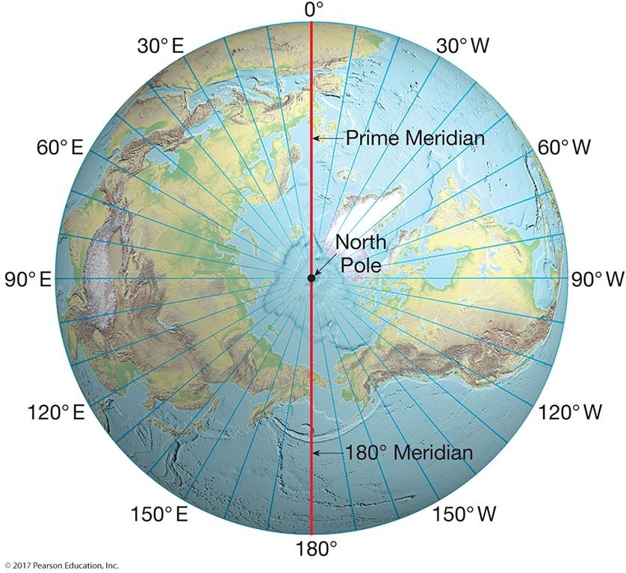

This figure shows a view of Earth from above the North Pole with meridians labeled. Meridians are also known as ________.
A) axes
B) parallels
C) planes of the ecliptic
D) diverging parallels
E) lines of longitude
Answer: E
Diff: 1
Topic/Section: 1.4 The Geographic Grid - Latitude and Longitude
Learning Outcome: 1.8 Discuss the implications of the fact that Earth is not quite spherical.
Natl. Geog Stds: GS1
Global Sci Stds: G3
Bloom's Taxonomy: Remembering/Understanding
62)
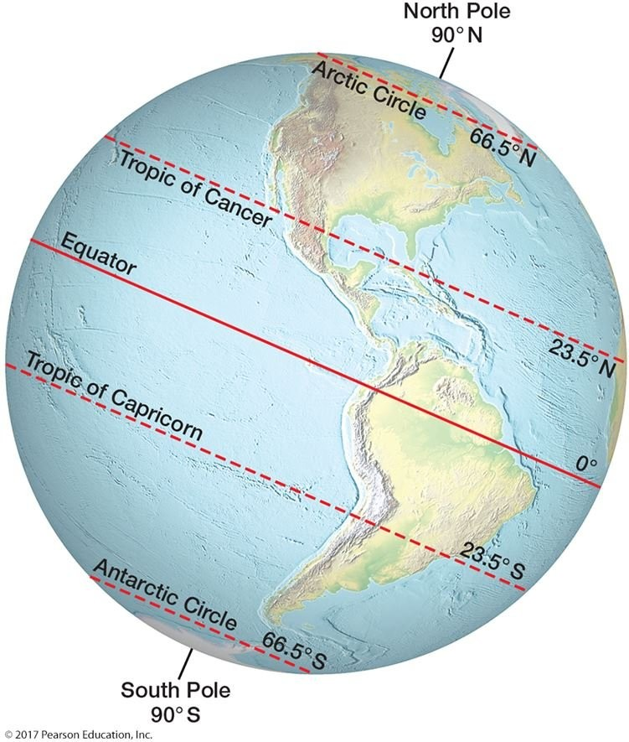

From this figure and your knowledge of which days the sun is directly overhead at various latitudes, you can calculate that the vertical rays of the sun pass over a total of ________ degrees of latitude in a year.
A) 23.5
B) 47
C) 94
D) 186
E) 360
Answer: C
Diff: 3
Topic/Section: 1.5 Earth-Sun Relations and the Seasons
Learning Outcome: 1.11 Determine the longitude of a location on Earth; 1.12 Explain how latitude and longitude together identify a location on Earth.
Natl. Geog Stds: GS4
Global Sci Stds: G3
Bloom's Taxonomy: Evaluating/Creating
63)
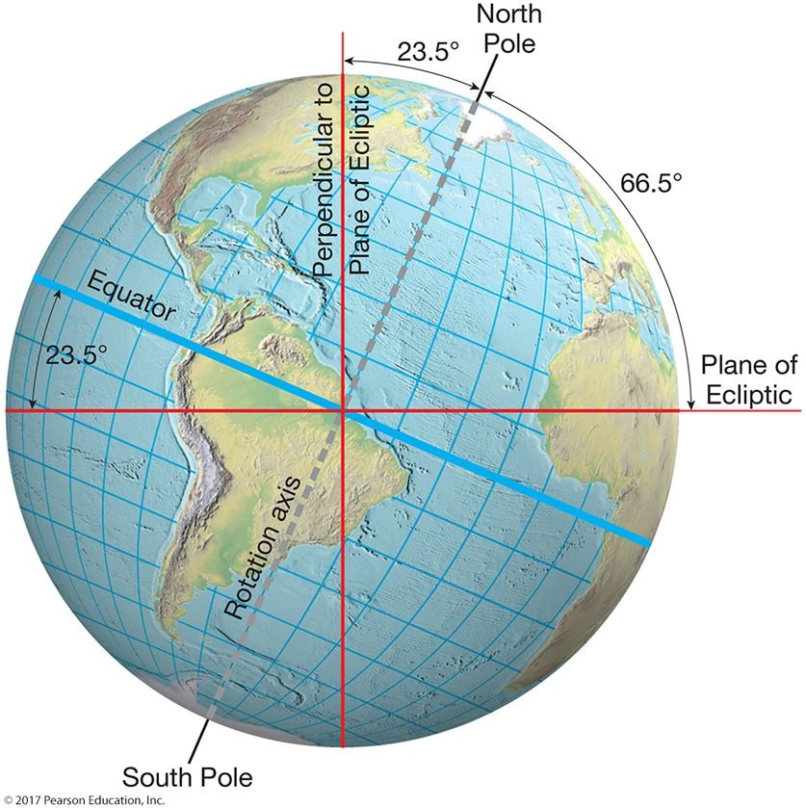

This figure shows that the Earth's axis and the plane of the ecliptic are ________.
A) the same line
B) not perpendicular to each other
C) wobbling with respect to each other
D) arranged so as to make seasons
E) quite different between the Northern and Southern hemispheres
Answer: B
Diff: 1
Topic/Section: 1.5 Earth-Sun Relations and the Seasons
Learning Outcome: 1.11 Determine the longitude of a location on Earth.
Natl. Geog Stds: GS7
Global Sci Stds: G3
Bloom's Taxonomy: Applying/Analyzing
64) The fact that at any time during the year, the Earth's axis is parallel to its orientation at all other times is called its parallelism, or ________.
A) revolution
B) rotation
C) polarity
D) aphelion
E) perihelion
Answer: C
Diff: 1
Topic/Section: 1.5 Earth-Sun Relations and the Seasons
Learning Outcome: 1.11 Determine the longitude of a location on Earth.
Natl. Geog Stds: GS7
Global Sci Stds: G2
Bloom's Taxonomy: Remembering/Understanding

65) The closest position taken by the Earth relative to the Sun is ________ million kilometers (miles).
A) 10 (6.21 miles)
B) 47 (29.20 miles)
C) 147 (91.34 miles)
D) 1,470 (913.41 miles)
E) 14,700 (9134.15 miles)
Answer: C
Diff: 1
Topic/Section: 1.5 Earth-Sun Relations and the Seasons
Learning Outcome: 1.11 Determine the longitude of a location on Earth.
Natl. Geog Stds: GS7
Global Sci Stds: G2
Bloom's Taxonomy: Remembering/Understanding

66) The Earth-Sun aphelion occurs once per year during the month of ________.
A) January
B) March
C) July
D) December
E) September
Answer: C
Diff: 1
Topic/Section: 1.5 Earth-Sun Relations and the Seasons
Learning Outcome: 1.11 Determine the longitude of a location on Earth.
Natl. Geog Stds: GS7
Global Sci Stds: G2
Bloom's Taxonomy: Remembering/Understanding
67) The most important physical effect of the Earth's rotation is ________.
A) to cause continents to "drift"
B) seasonal change
C) the alternation between sunlight and darkness
D) daylight saving time
E) the blue appearance of clear sky
Answer: C
Diff: 1
Topic/Section: 1.5 Earth-Sun Relations and the Seasons
Learning Outcome: 1.11 Determine the longitude of a location on Earth.
Natl. Geog Stds: GS7
Global Sci Stds: G2
Bloom's Taxonomy: Remembering/Understanding

68) The angular inclination of the Earth's axis with respect to a line perpendicular to the plane of the ecliptic ________.
A) varies through the year
B) is 0°
C) is 23.5°
D) is 66.5°
E) is 90°
Answer: C
Diff: 2
Topic/Section: 1.5 Earth-Sun Relations and the Seasons
Learning Outcome: 1.11 Determine the longitude of a location on Earth.
Natl. Geog Stds: GS7
Global Sci Stds: G2
Bloom's Taxonomy: Applying/Analyzing

69) The perihelion is during the month of ________.
A) January
B) March
C) July
D) September
E) December
Answer: A
Diff: 1
Topic/Section: 1.5 Earth-Sun Relations and the Seasons
Learning Outcome: 1.7 Compare the size of Earth with the size of its surface features; 1.11 Determine the longitude of a location on Earth.
Natl. Geog Stds: GS7
Global Sci Stds: G3
Bloom's Taxonomy: Remembering/Understanding
70)
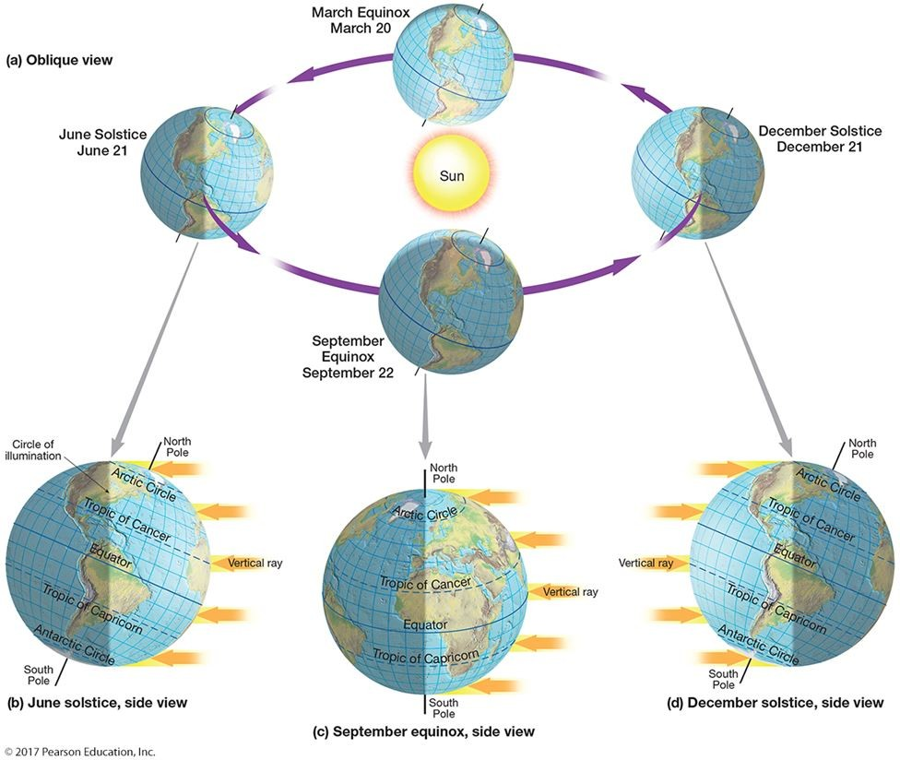

This figure shows that the most fundamental cause of the annual march of seasons is that ________.
A) the yearly solar energy totals vary by hemisphere
B) the orientation of the North Pole changes with respect to the sun
C) March has the longest day lengths in the Northern Hemisphere
D) December has the shortest day lengths in the Southern Hemisphere
E) the northern end of Earth's axis is oriented towards the sun all year
Answer: B
Diff: 2
Topic/Section: 1.5 Earth-Sun Relations and the Seasons
Learning Outcome: 1.11 Determine the longitude of a location on Earth.
Natl. Geog Stds: GS7
Global Sci Stds: G3
Bloom's Taxonomy: Applying/Analyzing
71) Rotation of the Earth DOES NOT cause ________.
A) tides
B) Coriolis effect
C) local variations in temperature
D) day and night
E) seasons
Answer: E
Diff: 2
Topic/Section: 1.5 Earth-Sun Relations and the Seasons
Learning Outcome: 1.11 Determine the longitude of a location on Earth.
Natl. Geog Stds: GS7
Global Sci Stds: G3
Bloom's Taxonomy: Applying/Analyzing

72) If the axis of the Earth were not tilted, Earth would not experience ________.
A) day/night variations
B) rotation
C) aphelions
D) perihelions
E) seasons
Answer: E
Diff: 2
Topic/Section: 1.5 Earth-Sun Relations and the Seasons
Learning Outcome: 1.11 Determine the longitude of a location on Earth.
Natl. Geog Stds: GS7
Global Sci Stds: G2
Bloom's Taxonomy: Applying/Analyzing

73) In the Northern Hemisphere in July, day lengths are ________ as one travels from the equator to the North Pole.
A) progressively longer
B) progressively shorter
C) the shortest of the year
D) the longest of the year
E) unchanged
Answer: A
Diff: 2
Topic/Section: 1.5 Earth-Sun Relations and the Seasons
Learning Outcome: 1.11 Determine the longitude of a location on Earth.
Natl. Geog Stds: GS7
Global Sci Stds: G2
Bloom's Taxonomy: Applying/Analyzing
74) The cause of Earth's seasons is the ________.
A) varying output of the Sun
B) polarity of the its axis
C) shape of the Earth
D) varying distance between the Earth and the Sun
E) cold experienced each wintertime
Answer: B
Diff: 1
Topic/Section: 1.5 Earth-Sun Relations and the Seasons
Learning Outcome: 1.11 Determine the longitude of a location on Earth.
Natl. Geog Stds: GS7
Global Sci Stds: G2
Bloom's Taxonomy: Remembering/Understanding

75)
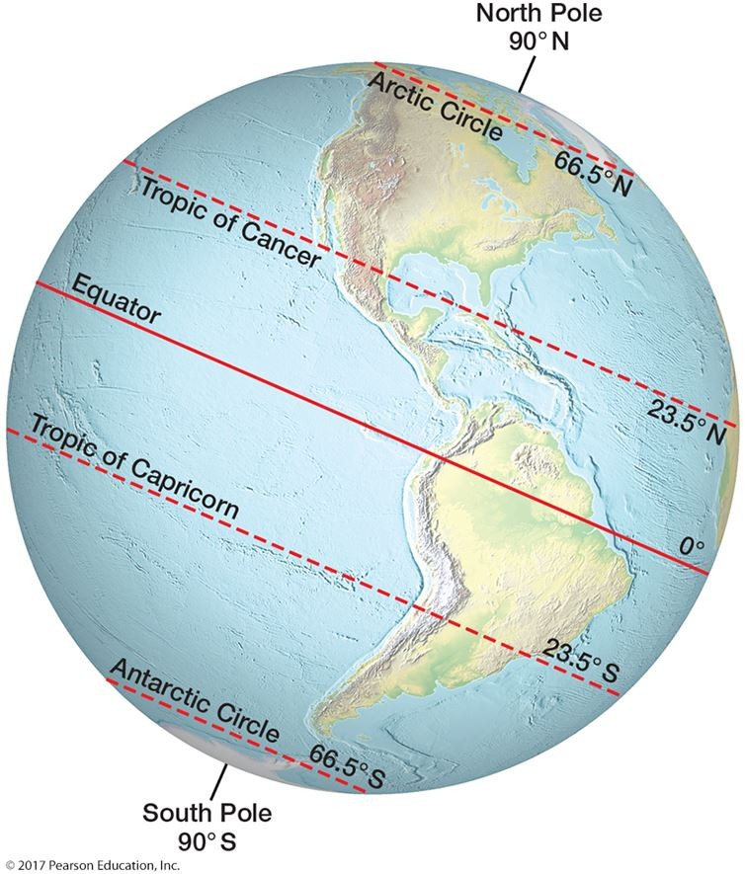

What would happen to the seasons if Earth's axis were perpendicular to the plane of the ecliptic?
A) Each season would become longer.
B) Each season would become shorter.
C) The perihelion would change seasons.
D) The aphelion would change seasons.
E) Seasons would not exist.
Answer: E
Diff: 2
Topic/Section: 1.5 Earth-Sun Relations and the Seasons
Learning Outcome: 1.7 Compare the size of Earth with the size of its surface features; 1.11 Determine the longitude of a location on Earth.
Natl. Geog Stds: GS7
Global Sci Stds: G2
Bloom's Taxonomy: Applying/Analyzing

76) When the circle of illumination just touches the Arctic Circle and the North Pole is dark, the date is closest to ________.
A) March 23
B) June 21
C) September 23
D) December 21
E) July 4
Answer: D
Diff: 2
Topic/Section: 1.5 Earth-Sun Relations and the Seasons
Learning Outcome: 1.7 Compare the size of Earth with the size of its surface features; 1.11 Determine the longitude of a location on Earth.
Natl. Geog Stds: GS7
Global Sci Stds: G2
Bloom's Taxonomy: Applying/Analyzing

77) The north end of Earth's axis points towards ________.
A) the Moon
B) Mars
C) Venus
D) Ork
E) Polaris
Answer: E
Diff: 2
Topic/Section: 1.5 Earth-Sun Relations and the Seasons
Learning Outcome: 1.11 Determine the longitude of a location on Earth.
Natl. Geog Stds: GS7
Global Sci Stds: G2
Bloom's Taxonomy: Applying/Analyzing

78) The distance of 150,000,000 kilometers is CLOSEST to being ________.
A) the aphelion
B) the perihelion
C) the circle of illumination
D) a light year
E) the average Earth-Sun distance
Answer: E
Diff: 2
Topic/Section: 1.5 Earth-Sun Relations and the Seasons
Learning Outcome: 1.11 Determine the longitude of a location on Earth.
Natl. Geog Stds: GS7
Global Sci Stds: G2
Bloom's Taxonomy: Applying/Analyzing
79) The amount of time the Earth takes to revolve around the Sun is most properly known as a(n) ________.
A) astronomical unit
B) season
C) tropical year
D) Earth sol
E) great circle period
Answer: C
Diff: 1
Topic/Section: 1.5 Earth-Sun Relations and the Seasons
Learning Outcome: 1.11 Determine the longitude of a location on Earth.
Natl. Geog Stds: GS7
Global Sci Stds: G2
Bloom's Taxonomy: Remembering/Understanding

80)
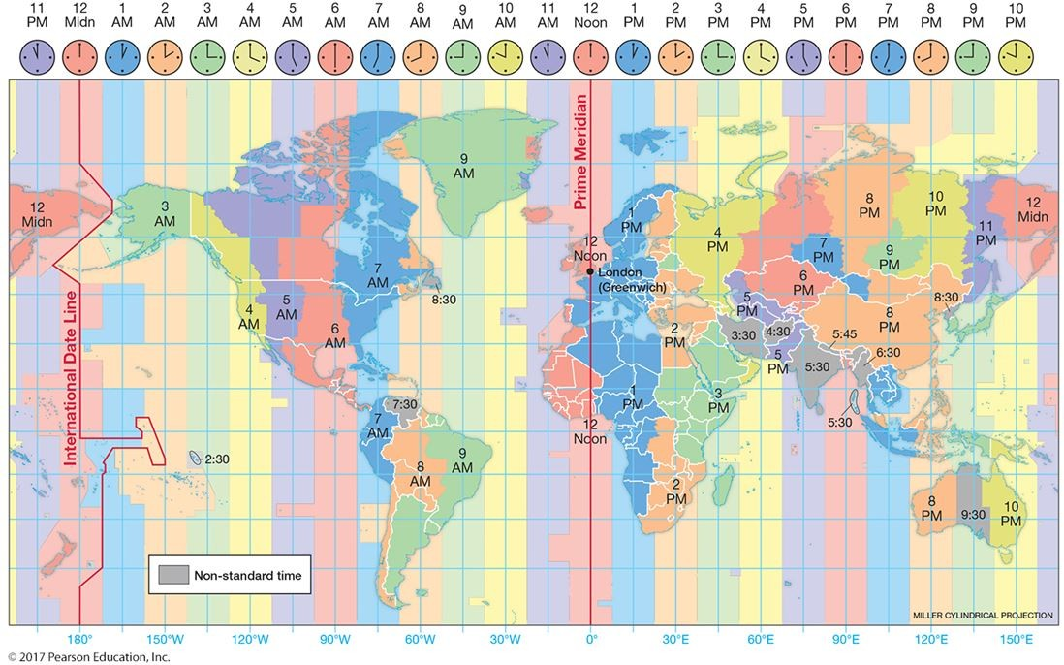

The deviation of time zones covering 15 degrees of longitude is due to ________.
A) organizing according to latitude
B) covering 15 degrees of longitude
C) covering 25 hours around the world
D) significant adjustments by individual countries
E) the 2 hours difference from adjacent time zones
Answer: D
Diff: 2
Topic/Section: 1.6 Telling Time
Learning Outcome: 1.13 Locate a place, given its latitude and longitude coordinates.
Natl. Geog Stds: GS3
Global Sci Stds: G3
Bloom's Taxonomy: Applying/Analyzing
81) In 1519, Ferdinand Magellan ________.
A) correctly calculated the size of the Earth
B) invented the Mercator Projection for sailing
C) started circumnavigating the Earth
D) discovered Earth's tallest peak
E) became the first person to sail across the Atlantic from west to east
Answer: C
Diff: 1
Topic/Section: 1.6 Telling Time
Learning Outcome: 1.15 Describe the changes in the patterns of sunlight around Earth on the June solstice, the September equinox, the December solstice, and the March equinox.
Natl. Geog Stds: GS4
Global Sci Stds: G2
Bloom's Taxonomy: Remembering/Understanding

82) "Greenwich Mean Time" is also known as ________.
A) Universal Time Coordinated
B) European time
C) the perihelion
D) Polaris
E) the plane of the ecliptic
Answer: A
Diff: 2
Topic/Section: 1.6 Telling Time
Learning Outcome: 1.13 Locate a place, given its latitude and longitude coordinates.
Natl. Geog Stds: GS5
Global Sci Stds: G2
Bloom's Taxonomy: Remembering/Understanding

83) When telling time, the term "a.m." ________.
A) was first used in the 1880s
B) refers to standard time at Greenwich
C) is no longer used by most of the world
D) means "before solar noon"
E) means "at solar noon"
Answer: D
Diff: 2
Topic/Section: 1.6 Telling Time
Learning Outcome: 1.13 Locate a place, given its latitude and longitude coordinates.
Natl. Geog Stds: GS5
Global Sci Stds: G2
Bloom's Taxonomy: Applying/Analyzing
84) Before time zones were created in the 1880s, one could encounter ________ local times during a rail trip across the United States.
A) no
B) 1
C) 2
D) 3
E) many
Answer: E
Diff: 1
Topic/Section: 1.6 Telling Time
Learning Outcome: 1.13 Locate a place, given its latitude and longitude coordinates.
Natl. Geog Stds: GS7
Global Sci Stds: G2
Bloom's Taxonomy: Remembering/Understanding

85) The United States spans ________ time zones.
A) 3
B) 6
C) 12
D) 24
E) 36
Answer: B
Diff: 1
Topic/Section: 1.6 Telling Time
Learning Outcome: 1.14 Summarize the factors that cause the annual change of seasons.
Natl. Geog Stds: GS7
Global Sci Stds: G2
Bloom's Taxonomy: Remembering/Understanding

86) The standardization of world time zones dates from ________.
A) 1584
B) 1684
C) 1784
D) 1884
E) 1984
Answer: D
Diff: 1
Topic/Section: 1.6 Telling Time
Learning Outcome: 1.13 Locate a place, given its latitude and longitude coordinates.
Natl. Geog Stds: GS5
Global Sci Stds: G2
Bloom's Taxonomy: Remembering/Understanding
87) A standard time zone extends ________ degrees of longitude to the east and west of the central meridian.
A) 5
B) 7.5
C) 15
D) 25
E) 50
Answer: B
Diff: 1
Topic/Section: 1.6 Telling Time
Learning Outcome: 1.13 Locate a place, given its latitude and longitude coordinates; 1.14 Summarize the factors that cause the annual change of seasons.
Natl. Geog Stds: GS5
Global Sci Stds: G2
Bloom's Taxonomy: Remembering/Understanding

88) The world is divided into ________ standard time zones.
A) 11
B) 15
C) 24
D) 180
E) 360
Answer: C
Diff: 2
Topic/Section: 1.6 Telling Time
Learning Outcome: 1.14 Summarize the factors that cause the annual change of seasons.
Natl. Geog Stds: GS5
Global Sci Stds: G2
Bloom's Taxonomy: Applying/Analyzing

89) Which of the following is a central meridian in the standardized time system?
A) 5°W
B) 10°W
C) 15°W
D) 20°W
E) 25°W
Answer: C
Diff: 2
Topic/Section: 1.6 Telling Time
Learning Outcome: 1.14 Summarize the factors that cause the annual change of seasons.
Natl. Geog Stds: GS5
Global Sci Stds: G2
Bloom's Taxonomy: Applying/Analyzing
90) Suppose you are standing on the standard time meridian of 75°W. Which would be the next standard time meridian to your west?
A) 76°W
B) 90°W
C) 180°W
D) 100°W
E) 235°W
Answer: B
Diff: 2
Topic/Section: 1.6 Telling Time
Learning Outcome: 1.14 Summarize the factors that cause the annual change of seasons.
Natl. Geog Stds: GS5
Global Sci Stds: G2
Bloom's Taxonomy: Applying/Analyzing

91) At the places where 180 degrees of longitude and the International Date Line meet, there is a change of ________ as you cross the International Date Line.
A) season
B) hour
C) year
D) day
E) day and time zone
Answer: D
Diff: 2
Topic/Section: 1.6 Telling Time
Learning Outcome: 1.15 Describe the changes in the patterns of sunlight around Earth on the June solstice, the September equinox, the December solstice, and the March equinox.
Natl. Geog Stds: GS5
Global Sci Stds: G2
Bloom's Taxonomy: Applying/Analyzing

92) The adoption of Daylight Saving Time would be of little value for nations ________.
A) at high latitudes
B) at the middle latitudes
C) at the tropical latitudes
D) with long east/west (longitudinal) extent
E) at high altitudes
Answer: C
Diff: 1
Topic/Section: 1.6 Telling Time
Learning Outcome: 1.14 Summarize the factors that cause the annual change of seasons.
Natl. Geog Stds: GS5
Global Sci Stds: G2
Bloom's Taxonomy: Remembering/Understanding
93) The International Date Line ________.
A) is the same line as 180 degrees latitude
B) is the "baseline" for all time measurements
C) is drawn to avoid countries
D) passes through the United States
E) is an important line of latitude
Answer: C
Diff: 2
Topic/Section: 1.6 Telling Time
Learning Outcome: 1.15 Describe the changes in the patterns of sunlight around Earth on the June solstice, the September equinox, the December solstice, and the March equinox.
Natl. Geog Stds: GS7
Global Sci Stds: G2
Bloom's Taxonomy: Applying/Analyzing

94) One can tell when it is solar noon by observing ________.
A) the time of the sunrise
B) the length of shadows
C) a clock
D) a calendar
E) a graticule
Answer: B
Diff: 1
Topic/Section: 1.6 Telling Time
Learning Outcome: 1.14 Summarize the factors that cause the annual change of seasons.
Natl. Geog Stds: GS7
Global Sci Stds: G2
Bloom's Taxonomy: Remembering/Understanding

95) Write a paragraph explaining how geography is the same as other disciplines and is unique from other disciplines.
Answer: Geography seeks to gather knowledge in the same manner as other sciences; that is, Geography uses measurements and the methods of scientific inquiry. Geography differs from other disciplines because it seeks to integrate knowledge in a holistic way, across disciplines.
Diff: 3
Topic/Section: 1.1 Geography and Science
Learning Outcome: 1.2 Analyze how geographers use science to explain and understand the natural environment.
Natl. Geog Stds: GS4
Global Sci Stds: G1
Bloom's Taxonomy: Evaluating/Creating

96) You are studying Physical Geography. Speculate on why physical geographers should be interested in the patterns of globalization.
Answer: Worldwide connections within human geography translate into modifications to the physical environment and vice versa.
Diff: 3
Topic/Section: 1.1 Geography and Science
Learning Outcome: 1.2 Analyze how geographers use science to explain and understand the natural environment.
Natl. Geog Stds: GS4
Global Sci Stds: G2
Bloom's Taxonomy: Evaluating/Creating
97) Define equilibrium and give an example from within the Earth system.
Answer: This could be almost anything, but the answer should be couched in system's terms. For instance, in a stream drainage basin, water flows off the landscape and travels along the river to its mouth. If rainfall increases, then the flow at the mouth of the river should increase, and input and output should be approximately equal over time.
Diff: 2
Topic/Section: 1.2 Environmental Spheres and Earth Systems
Learning Outcome: 1.4 Identify the four environmental "spheres" of Earth.
Natl. Geog Stds: GS3
Global Sci Stds: G2
Bloom's Taxonomy: Applying/Analyzing

98) Write an essay differentiating between closed and open systems. Give an example of an open system from the physical Earth.
Answer: A closed system is one imparted with mass and energy, and neither the mass nor the energy ever leaves the system. In an open system mass and energy enters and leaves, but with work being done within the system. An example would be a local group of plants and animals working together as an ecosystem. Solar energy and solar energy are inputs. The plants and animals are able to live from these inputs, and mass and energy leave the system through metabolic heat loss, and so on.
Diff: 2
Topic/Section: 1.2 Environmental Spheres and Earth Systems
Learning Outcome: 1.4 Identify the four environmental "spheres" of Earth.
Natl. Geog Stds: GS3
Global Sci Stds: G2
Bloom's Taxonomy: Applying/Analyzing

99) Suppose you lived on the Falkland Islands at 52 degrees south latitude. Describe the basic changes in the angle of the Sun in the sky, and the length of the day as time progresses from January to December at your latitude.
Answer: The sun moves in an opposite pattern from that in the Northern Hemisphere. The highest and lowest angles could be mentioned.
Diff: 3
Topic/Section: 1.5 Earth-Sun Relations and the Seasons
Learning Outcome: 1.11 Determine the longitude of a location on Earth.
Natl. Geog Stds: GS7
Global Sci Stds: G2
Bloom's Taxonomy: Applying/Analyzing

100) Write a paragraph explaining the physical basis of standard time zones.
Answer: The Earth's rotation makes the highest sun of the day (solar noon) pass westward over 15° of longitude per hour. In 24 hours, the sun passes over 360° of longitude (15° per hour times 24 hours equals 360°). Thus, there is one theoretical time zone per 15° of longitude.
Diff: 3
Topic/Section: 1.6 Telling Time
Learning Outcome: 1.14 Summarize the factors that cause the annual change of seasons; 1.15 Describe the changes in the patterns of sunlight around Earth on the June solstice, the September equinox, the December solstice, and the March equinox.
Natl. Geog Stds: GS3
Global Sci Stds: G2, G4
Bloom's Taxonomy: Evaluating/Creating
101) Explain why the following lines are crucial to physical geography: North Pole, South Pole, Tropic of Capricorn, and the International Date Line.
Answer: The North and South Poles are at the ends of the Earth's axis of rotation. Lines of latitude: solar energy distribution. Lines of longitude: time. Plane of the ecliptic: orbital plane of Earth. Equator: center of the migrating declination of the Sun.
Diff: 3
Topic/Section: 1.4 The Geographic Grid - Latitude and Longitude
Learning Outcome: 1.7 Compare the size of Earth with the size of its surface features; 1.8 Discuss the implications of the fact that Earth is not quite spherical.
Natl. Geog Stds: GS1
Global Sci Stds: G2
Bloom's Taxonomy: Evaluating/Creating

102) Explain the progression of the months and the latitudes of declination of the Sun through the year, and the named Earth-Sun days involved.
Answer: For the Northern Hemisphere: March, spring equinox, and equator; June, summer solstice, and the Tropic of Cancer; September, fall equinox, and the equator; and December, winter solstice, and the Tropic of Cancer.
Diff: 3
Topic/Section: 1.5 Earth-Sun Relations and the Seasons
Learning Outcome: 1.11 Determine the longitude of a location on Earth.
Natl. Geog Stds: GS7
Global Sci Stds: G2
Bloom's Taxonomy: Evaluating/Creating

103) Use the steps of the scientific method to devise an experiment to discover the shape of the Earth. Your answer might not use all the steps in order: Observe phenomena, hypothesis, predict the outcome of the experiment if the hypothesis is supported or unsupported, conduct the experiment and observe what actually happens, and draw conclusions or make a "rule" from your results. You may use any kind of equipment without worrying about the expense.
Answer: An example would be to find that the Earth is "round" by sending a satellite aloft to record the shape with imagery.
Diff: 2
Topic/Section: 1.4 The Geographic Grid - Latitude and Longitude
Learning Outcome: 1.14 Summarize the factors that cause the annual change of seasons; 1.15 Describe the changes in the patterns of sunlight around Earth on the June solstice, the September equinox, the December solstice, and the March equinox.
Natl. Geog Stds: GS5
Global Sci Stds: G2
Bloom's Taxonomy: Applying/Analyzing

104) China has one time zone; yet, it is as large as the mainland of the United States, which has four time zones. Speculate on why this is so.
Answer: Each country is free to suit itself, and China wants all its citizens to be on the same time no matter what the physical solar time. It is a matter of the physical being subservient to the social!
Diff: 3
Topic/Section: 1.6 Telling Time
Learning Outcome: 1.14 Summarize the factors that cause the annual change of seasons; 1.15 Describe the changes in the patterns of sunlight around Earth on the June solstice, the September equinox, the December solstice, and the March equinox.
Natl. Geog Stds: GS3
Global Sci Stds: G2
Bloom's Taxonomy: Evaluating/Creating
105) Describe the Earth-Sun relationship that causes seasonality.
Answer: Earth rotates on the plane of the ecliptic. The axis is always at an angle of 66.5º from the plane of the ecliptic. This means that the Northern Hemisphere is sometimes pointed towards, and at other times away, from the Sun. This systematically changes the day lengths and the angle of the Sun above the horizon throughout the year; these changes cause the seasons.
Diff: 3
Topic/Section: 1.5 Earth-Sun Relations and the Seasons
Learning Outcome: 1.11 Determine the longitude of a location on Earth.
Natl. Geog Stds: GS7
Global Sci Stds: G2
Bloom's Taxonomy: Evaluating/Creating

